**List of Certification for AI Assisted Coding**

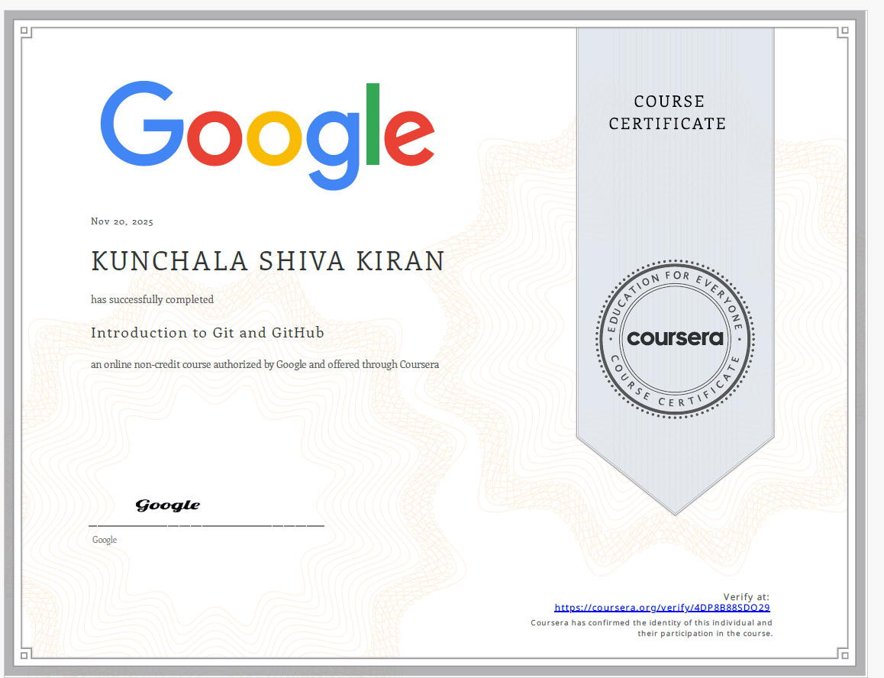

**Certification#1**

Title: Introduction to Git and GitHub

Link: <https://infyspringboard.onwingspan.com/web/en/app/toc/lex_auth_014218482113093632326/overview>

Duration: 20Hours

Marks: 3.0

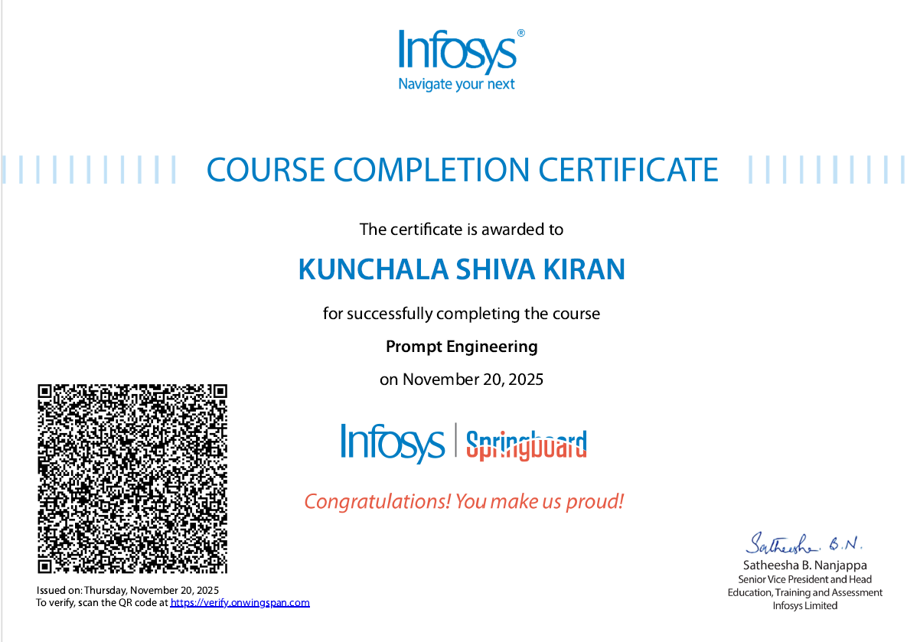

**Certification#2**

Title: Prompt Engineering

Link: <https://infyspringboard.onwingspan.com/web/en/app/toc/lex_auth_013719953643773952304_shared/overview>

Duration: 3 Hours

Marks: 0.5

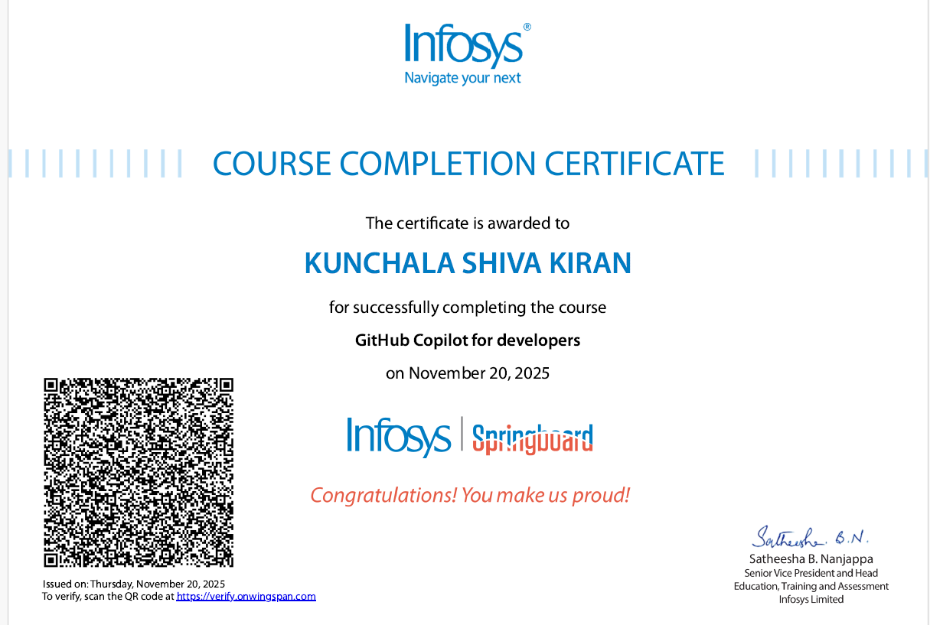

**Certification#3**

Title: GitHub Copilot for developers

Link: <https://infyspringboard.onwingspan.com/web/en/app/toc/lex_auth_013749091701841920319_shared/overview>

Duration: 7 Hours

Marks: 0.5

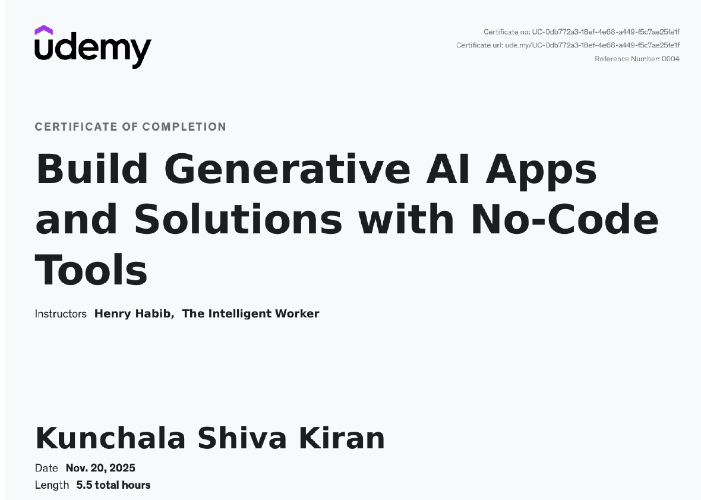

**Certification#4**

Title: Build Generative AI Apps and Solutions with No-Code Tools

Link: <https://infyspringboard.onwingspan.com/web/en/app/toc/lex_auth_014157683688415232146/overview>

Duration: 5 Hours

Marks: 0.5

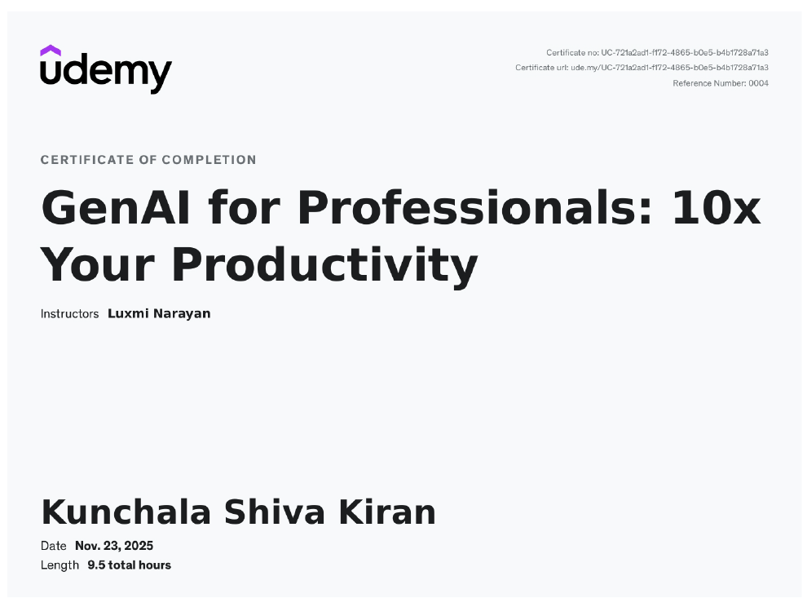

**Certification#5**

Title: GenAI for IT: Transforming IT with Generative AI

Link: <https://infyspringboard.onwingspan.com/web/en/app/toc/lex_auth_014157698985598976246/overview>

Duration: 6 Hours

Marks: 0.5

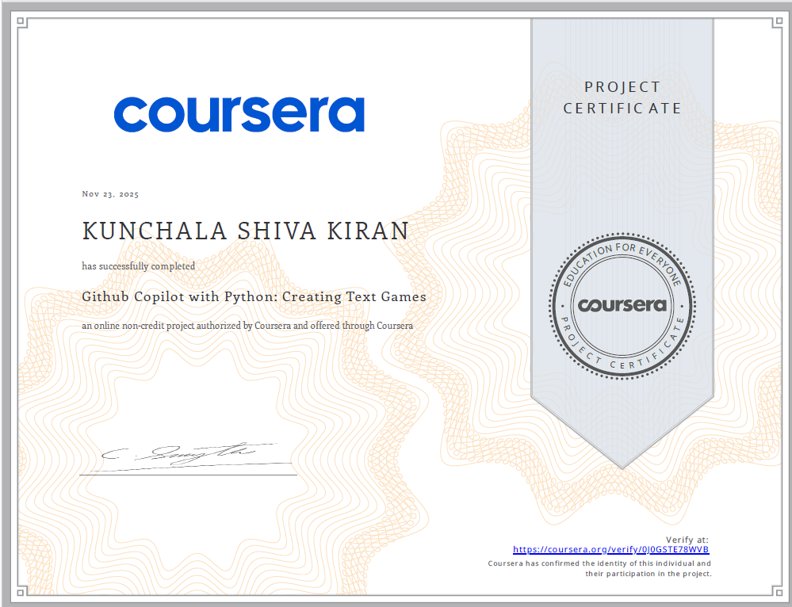

**Certification#6**

Title: Github Copilot with Python: Creating Text Games

Link: <https://infyspringboard.onwingspan.com/web/en/app/toc/lex_auth_014222732610756608908/overview>

Duration: 2 Hours

Marks: 0.5

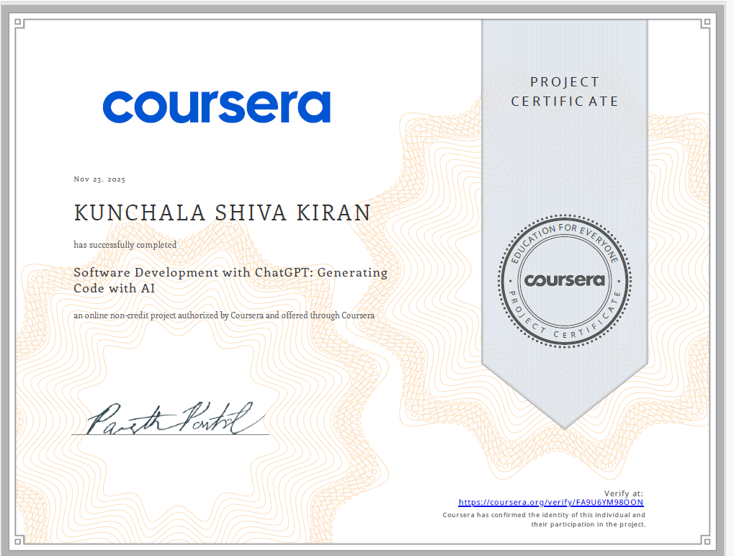

**Certification#7**

Title: Software Development with ChatGPT: Generating Code with AI

Link: <https://infyspringboard.onwingspan.com/web/en/app/toc/lex_auth_0142227377610997761294/overview>

Duration: 3 Hours

Marks: 0.5

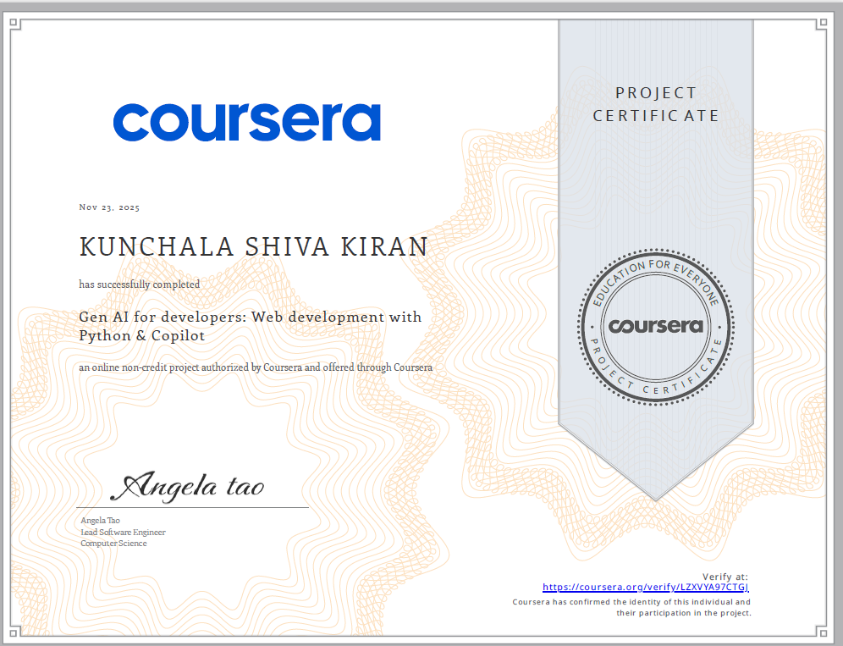

**Certification#8**

Title: Gen AI for developers: Web development with Python & Copilot

Link: <https://infyspringboard.onwingspan.com/web/en/app/toc/lex_auth_0142354051890954242944/overview>

Duration: 3 Hours

Marks: 0.5

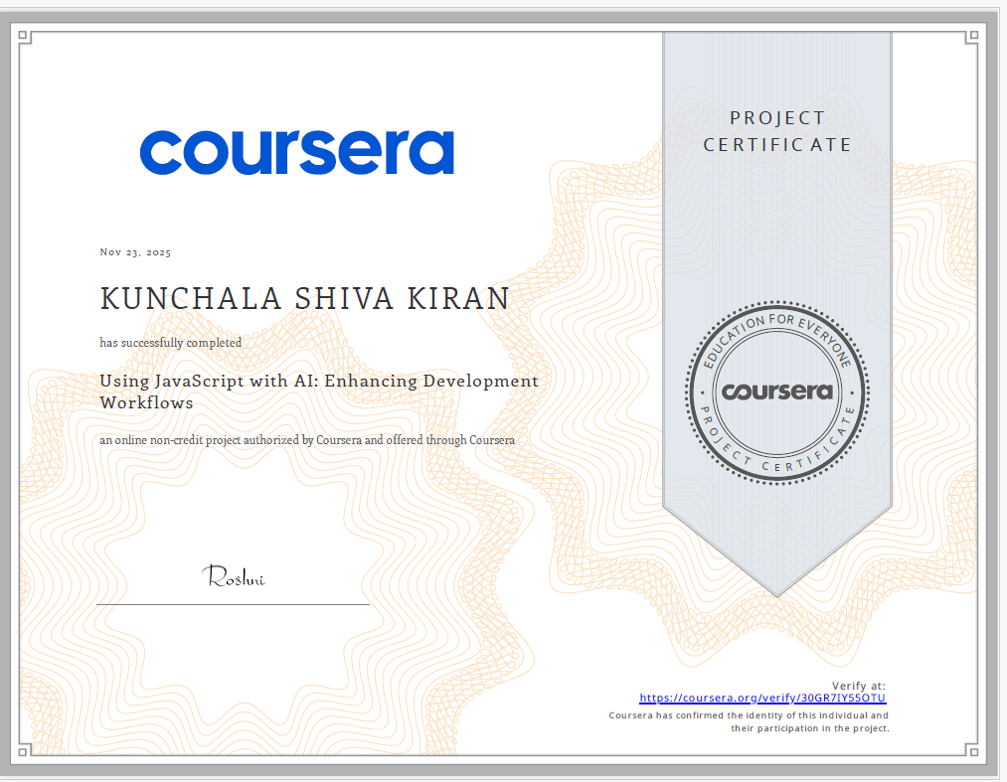

**Certification#9**

Title: Using JavaScript with AI: Enhancing Development Workflows

Link: <https://infyspringboard.onwingspan.com/web/en/app/toc/lex_auth_014222738755936256945/overview>

Duration: 3 Hours

Marks: 0.5

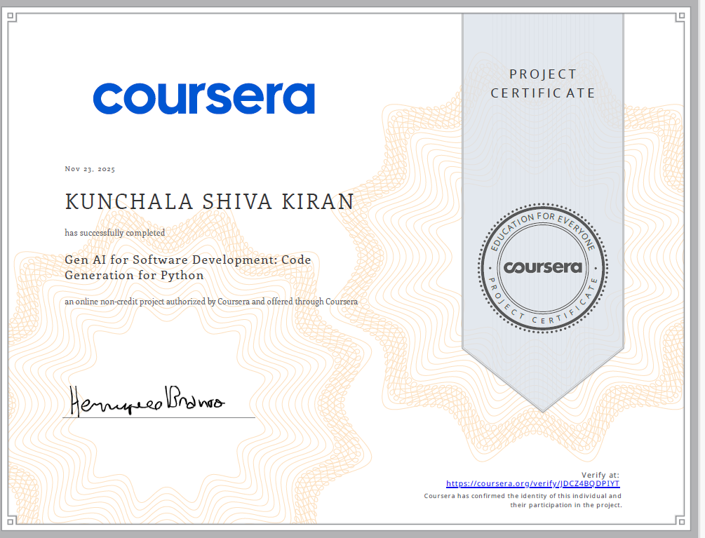

**Certification#10**

Title: Gen AI for Software Development: Code Generation for Python

Link: <https://infyspringboard.onwingspan.com/web/en/app/toc/lex_auth_0142227476144947202012/overview>

Duration: 3 Hours

Marks: 0.5

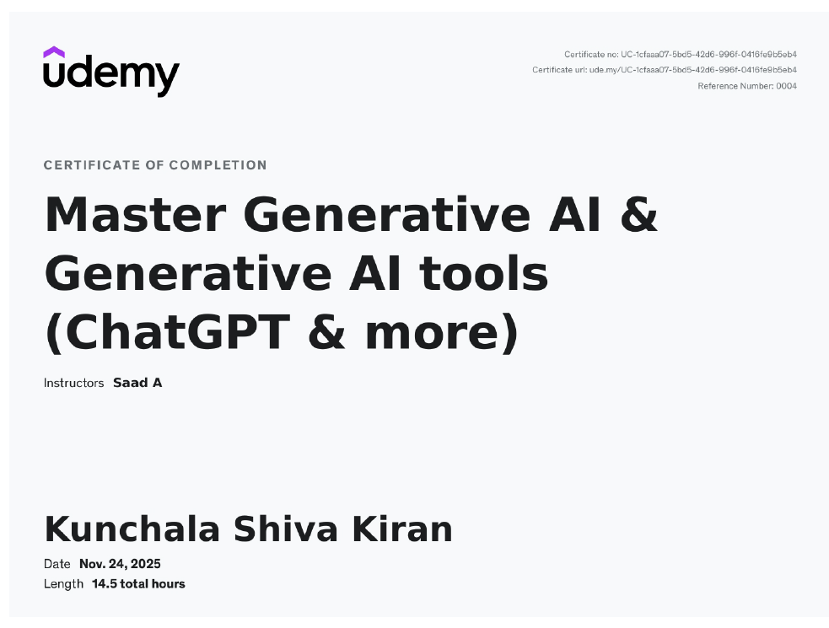

**Certification#11**

Title: Master Generative AI & Generative AI tools (ChatGPT & more)

Link: <https://infyspringboard.onwingspan.com/web/en/app/toc/lex_auth_014157710267834368237/overview>

Duration: 10 Hours

Marks: 1.5

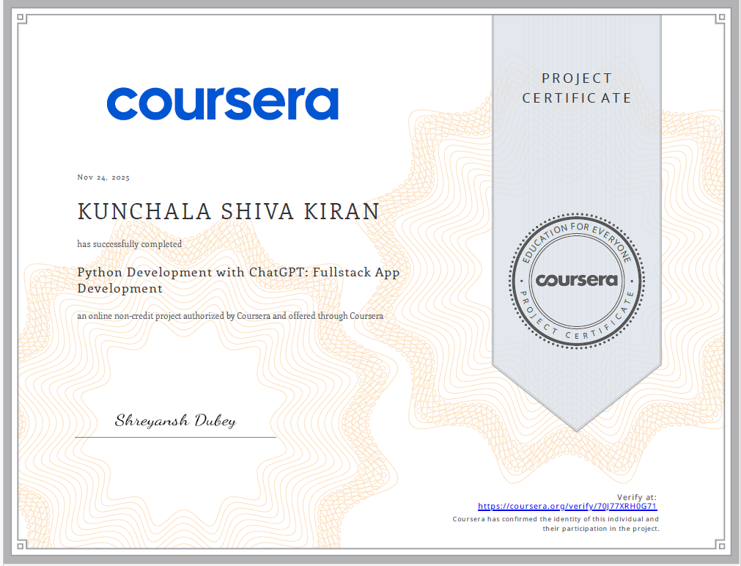

**Certification#12**

Title: Python Development with ChatGPT: Fullstack App Development

Link: <https://infyspringboard.onwingspan.com/web/en/app/toc/lex_auth_0142227511742873602062/overview>

Duration: 3 Hours

Marks: 0.5

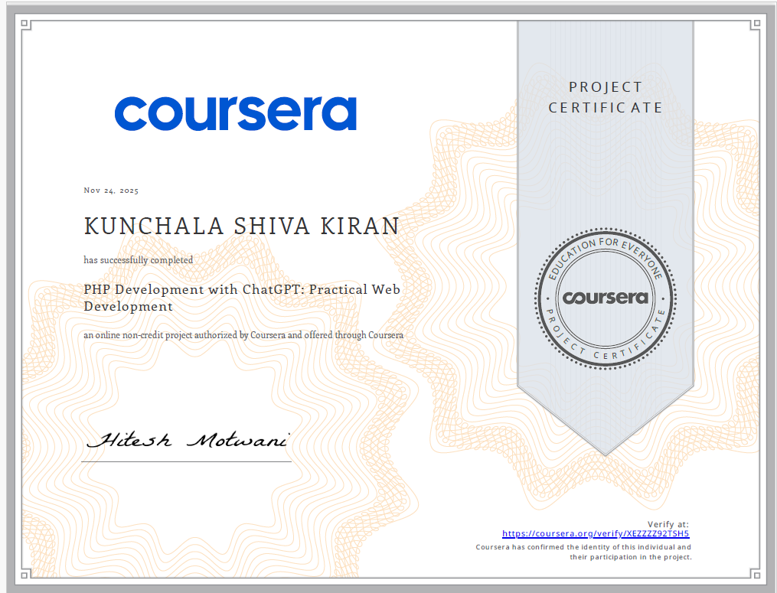

**Certification#13**

Title: PHP Development with ChatGPT: Practical Web Development

Link: <https://infyspringboard.onwingspan.com/web/en/app/toc/lex_auth_0142354073538396162597/overview>

Duration: 3 Hours

Marks: 0.5

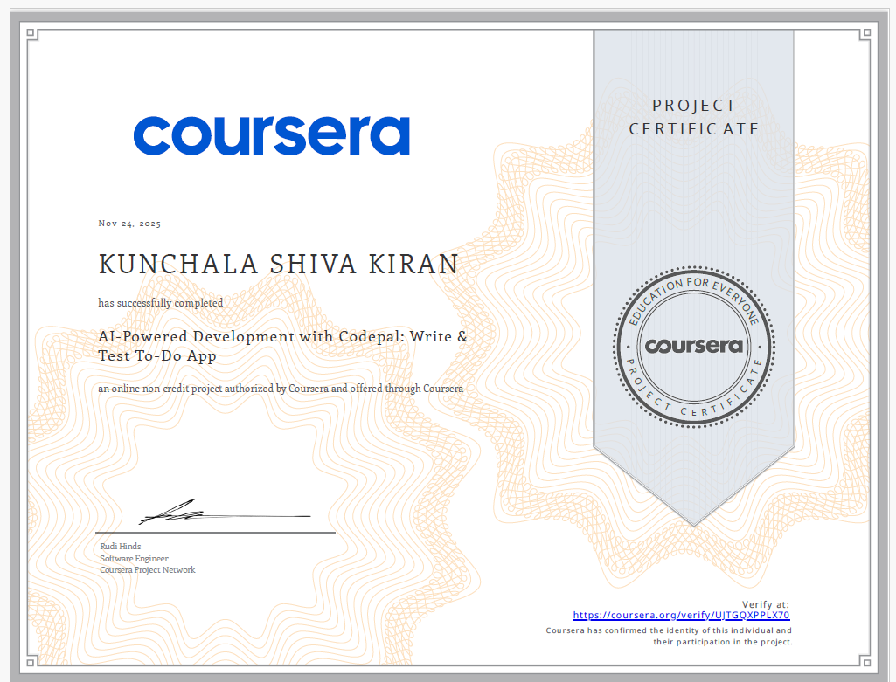

**Certification#14**

Title: AI-Powered Development with Codepal: Write & Test To-Do App

Link: <https://infyspringboard.onwingspan.com/web/en/app/toc/lex_auth_0142354137550438403139/overview>

Duration: 3 Hours

Marks: 0.5